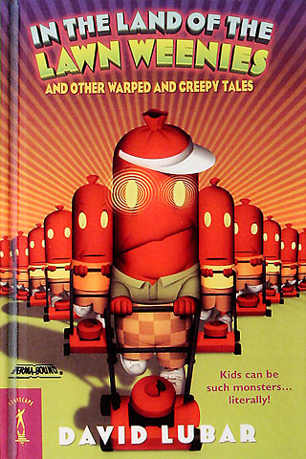

**Who**: Attention all Fourth and Fifth Grade students

**What**: David Lubar Writing Activity

Amazing author and Morristown, NJ native, will be visiting our school on March 18, 2014. To celebrate his arrival, we invite you to complete an activity based on his ever popular “Weenies” short stories. These stories combine mystery, adventure, thrills, frights, and laughter as they answer some age- old questions.

**Activity:** In David Lubar’s short story, “Slugs” taken from the book, In the Land of the Lawn Weenies, we read about a group of kids that chase their baseball into the yard of a spooky old woman’s house. It is there that they discover she is also a magical and wonderful person who has the power to transforms each child into whatever animal represents their true nature. In 1 to 2 paragraphs, choose and write about the animal that best describes your personality. Please be sure to include examples of why you chose this animal.

**When**: Entries must be handed in by Wednesday, March 12, 2014.

**Where**: Entries must be submitted to Mr. Mullarkey in the library.

**Why**: To celebrate the arrival of David Lubar and earn the chance to share dessert with him! All students who complete the activity will be entered into a drawing, and several students will be selected randomly to have dessert with Mr. Lubar.

Please be sure to include your name and grade!